Title of Culminating Experience
A Choose an item. submitted to the faculty of
San Francisco State University
In partial fulfillment of
the requirements for
the Degree
Click to choose Degree
In
Click to choose Major: Concentration
by
First Middle Last Name
San Francisco, California
Click to choose Semester 20XX

Copyright by
First Middle Last Name
20XX

Certification of Approval
I certify that I have read Title of Culminating Experience by First Middle Last Name, and that in my opinion this work meets the criteria for approving a thesis submitted in partial fulfillment of the requirement for the degree (Example) Master of Science in Biology: Conservation Biology at San Francisco State University.

Name of the professor, Choose degree
Click to choose the faculty rank,
Thesis Committee Chair

Name of the professor, Choose degree
Click to choose the faculty rank

Name of the professor, Choose degree
Click to choose the faculty rank

Name of the professor, Choose degree
Click to choose the faculty rank

Abstract
Begin your abstract here.

Insert a section break at the end of the Abstract by placing your cursor after the final punctuation and going to Layout > Breaks > Next Page (under Section Breaks). For corresponding screenshots, please consult Microsoft’s support page.

Preface
Including a Preface for your work is optional. If you do not have one, please delete this page.

[Insert a page break at the end of the Preface by placing your cursor after the final punctuation and going to Insert > Page Break.}

Acknowledgements
Normally the Acknowledgements section gives you the opportunity to thank those to whom you are indebted for assistance in the project. This should be done briefly and in good taste.

[Insert a page break at the end of the Acknowledgements by placing your cursor after the final punctuation and going to Insert > Page Break.]

Table of Contents
List of Tables ix
List of Figures x
List of Appendices xi
Introduction 1
Method 2
Chapter 1 3
Chapter 1 Heading 3 (Subheading) 4
Chapter 1 Heading 4 (Sub-subheading) 5
Chapter 2 6
References/Bibliography/Works Cited 9
Appendix/Appendices 10

[If your work includes a List of Tables, List of Figures, and/or List of Appendices, insert a page break at the end of the Table of Contents by placing your cursor at the bottom of the page and going to Insert > Page Break.

If your work does not include a List of Tables, List of Figures, and/or List of Appendices, insert a section break at the end of the Table of Contents by placing your cursor at the bottom of the page and going to Layout > Breaks > Next Page (under Section Breaks). For corresponding screenshots, please consult Microsoft’s support page.]

List of Tables
Table 1. Number of Students, 2016-2019 6
Table 2. Responses to Survey Question 1 7

[If your work includes a List of Figures and/or List of Appendices, insert a page break at the end of the List of Tables by placing your cursor at the bottom of the page and going to Insert > Page Break.

If your work does not include a List of Figures and/or List of Appendices, insert a section break at the end of the List of Tables by placing your cursor at the bottom of the page and going to Layout > Breaks > Next Page (under Section Breaks). For corresponding screenshots, please consult Microsoft’s support page.]

List of Figures
Figure 1. A sketch of Doullens town hall 4
Figure 2. Marine Algae in Sweden 7

[If your work includes a List of Appendices, insert a page break at the end of the List of Figures by placing your cursor at the bottom of the page and going to Insert > Page Break.

If your work does not include a List of Appendices, insert a section break at the end of the List of Figures by placing your cursor at the bottom of the page and going to Layout > Breaks > Next Page (under Section Breaks). For corresponding screenshots, please consult Microsoft’s support page.]

List of Appendices
Appendix A: List of California State University Campuses 9
Appendix B: Abbreviations of California State University Campuses 10

[Insert a section break at the end of the List of Appendices by placing your cursor at the bottom of the page and going to Layout > Breaks > Next Page (under Section Breaks). For corresponding screenshots, please consult Microsoft’s support page.]

Introduction
Lorem ipsum dolor sit amet, consectetuer adipiscing elit. Maecenas porttitor congue massa. Fusce posuere, magna sed pulvinar ultricies, purus lectus malesuada libero, sit amet commodo magna eros quis urna. Nunc viverra imperdiet enim. Fusce est. Vivamus a tellus.
Pellentesque habitant morbi tristique senectus et netus et malesuada fames ac turpis egestas. Proin pharetra nonummy pede. Mauris et orci. Aenean nec lorem. In porttitor. Donec laoreet nonummy augue.
Suspendisse dui purus, scelerisque at, vulputate vitae, pretium mattis, nunc. Mauris eget neque at sem venenatis eleifend. Ut nonummy. Fusce aliquet pede non pede. Suspendisse dapibus lorem pellentesque magna. Integer nulla.

Method
Donec blandit feugiat ligula. Donec hendrerit, felis et imperdiet euismod, purus ipsum pretium metus, in lacinia nulla nisl eget sapien. Donec ut est in lectus consequat consequat. Etiam eget dui. Aliquam erat volutpat. Sed at lorem in nunc porta tristique.
Proin nec augue. Quisque aliquam tempor magna. Pellentesque habitant morbi tristique senectus et netus et malesuada fames ac turpis egestas. Nunc ac magna. Maecenas odio dolor, vulputate vel, auctor ac, accumsan id, felis. Pellentesque cursus sagittis felis.

[Insert a page break at the end of each major section by placing your cursor after the final punctuation and going to Insert > Page Break.]

Chapter 1
Pellentesque porttitor, velit lacinia egestas auctor, diam eros tempus arcu, nec vulputate augue magna vel risus. Cras non magna vel ante adipiscing rhoncus. Vivamus a mi. Morbi neque. Aliquam erat volutpat. Integer ultrices lobortis eros.
Pellentesque habitant morbi tristique senectus et netus et malesuada fames ac turpis egestas. Proin semper, ante vitae sollicitudin posuere, metus quam iaculis nibh, vitae scelerisque nunc massa eget pede. Sed velit urna, interdum vel, ultricies vel, faucibus at, quam. Donec elit est, consectetuer eget, consequat quis, tempus quis, wisi. In in nunc. Class aptent taciti sociosqu ad litora torquent per conubia nostra, per inceptos hymenaeos.
Figure 1. A sketch of Doullens town hall
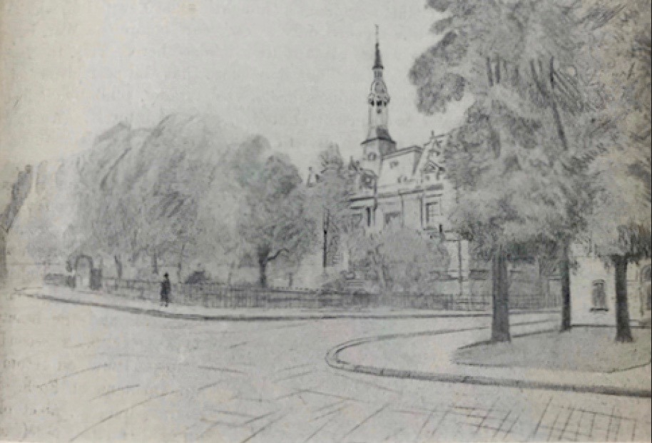
This sketch by W. Basil Worsfold was first published in "United Empire," Volume XX, London: Isaac Pitman, 1929, pg. 237. The image is in the public domain.
Donec ullamcorper fringilla eros. Fusce in sapien eu purus dapibus commodo. Cum sociis natoque penatibus et magnis dis parturient montes, nascetur ridiculus mus.

Chapter 1 Heading 3 (Subheading)
Cras faucibus condimentum odio. Sed ac ligula. Aliquam at eros. Etiam at ligula et tellus ullamcorper ultrices. In fermentum, lorem non cursus porttitor, diam urna accumsan lacus, sed interdum wisi nibh nec nisl. Ut tincidunt volutpat urna. Mauris eleifend nulla eget mauris. Sed cursus quam id felis. Curabitur posuere quam vel nibh. Cras dapibus dapibus nisl.
Vestibulum quis dolor a felis congue vehicula. Maecenas pede purus, tristique ac, tempus eget, egestas quis, mauris. Curabitur non eros. Nullam hendrerit bibendum justo. Fusce iaculis, est quis lacinia pretium, pede metus molestie lacus, at gravida wisi ante at libero. Quisque ornare placerat risus. Ut molestie magna at mi. Integer aliquet mauris et nibh. Ut mattis ligula posuere velit. Nunc sagittis.

Chapter 1 Heading 4 (Sub-subheading)
Curabitur varius fringilla nisl. Duis pretium mi euismod erat. Maecenas id augue. Nam vulputate. Duis a quam non neque lobortis malesuada. Praesent euismod. Donec nulla augue, venenatis scelerisque, dapibus a, consequat at, leo. Pellentesque libero lectus, tristique ac, consectetuer sit amet, imperdiet ut, justo. Sed aliquam odio vitae tortor. Proin hendrerit tempus arcu. In hac habitasse platea dictumst. Suspendisse potenti.

[Insert a page break at the end of each major section by placing your cursor after the final punctuation and going to Insert > Page Break.]

Chapter 2
Vivamus vitae massa adipiscing est lacinia sodales. Donec metus massa, mollis vel, tempus placerat, vestibulum condimentum, ligula. Nunc lacus metus, posuere eget, lacinia eu, varius quis, libero. Aliquam nonummy adipiscing augue. Lorem ipsum dolor sit amet, consectetuer adipiscing elit. Maecenas porttitor congue massa. Fusce posuere, magna sed pulvinar ultricies, purus lectus malesuada libero, sit amet commodo magna eros quis urna. Nunc viverra imperdiet enim.
Table 1. Number of Students, 2016-2019
Year | Number of Students
2016 | 12,923
2017 | 13,012
2018 | 11,065
2019 | 12,743
Table 1. A caption is optional, but it can be helpful to summarize the data and explain how a table relates to the surrounding text.
Fusce est. Vivamus a tellus. Pellentesque habitant morbi tristique senectus et netus et malesuada fames ac turpis egestas. Proin pharetra nonummy pede. Mauris et orci. Aenean nec lorem. In porttitor.
Donec laoreet nonummy augue. Suspendisse dui purus, scelerisque at, vulputate vitae, pretium mattis, nunc. Mauris eget neque at sem venenatis eleifend. Ut nonummy. Fusce aliquet pede non pede. Suspendisse dapibus lorem pellentesque magna. Integer nulla. Donec blandit feugiat ligula.
Table 2. Responses to Survey Question 1
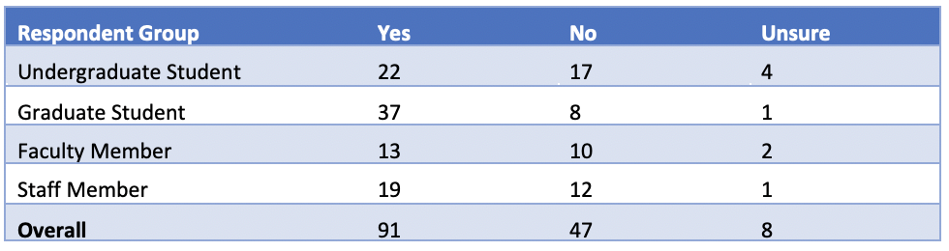
Table 1. A caption is optional, but it can be helpful to summarize the data and explain how a table relates to the surrounding text.
Donec hendrerit, felis et imperdiet euismod, purus ipsum pretium metus, in lacinia nulla nisl eget sapien. Donec ut est in lectus consequat consequat. Etiam eget dui. Aliquam erat volutpat. Sed at lorem in nunc porta tristique. Proin nec augue. Quisque aliquam tempor magna. Pellentesque habitant morbi tristique senectus et netus et malesuada fames ac turpis egestas.
Figure 2. Marine Algae in Sweden
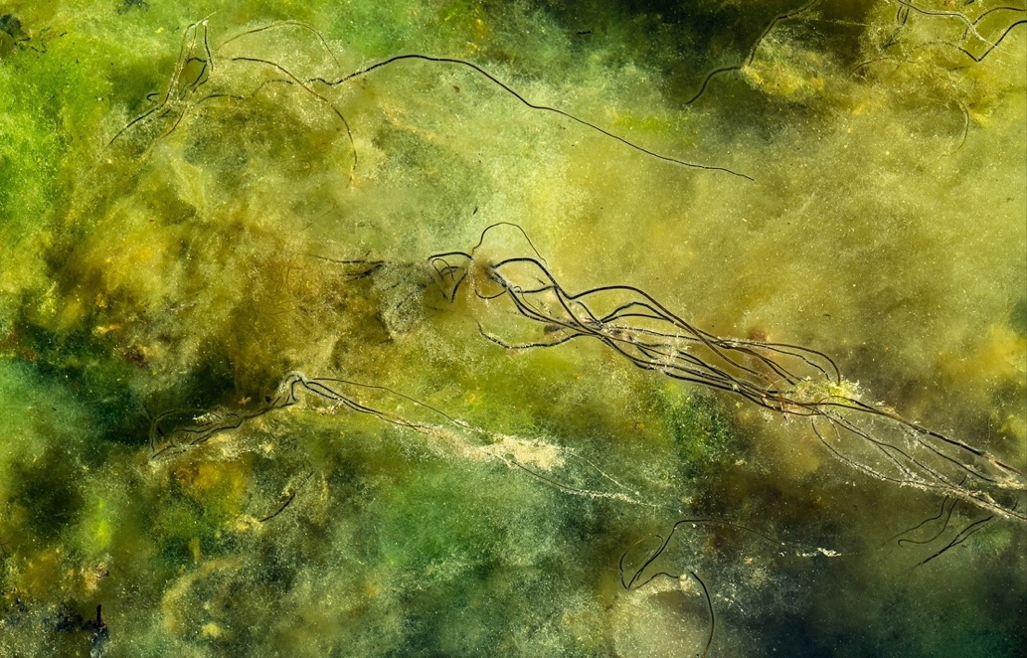
Figure 2. The Dead Man's Rope (Chorda filum) shown in this photograph are about 3.3 ft. high, and the bottom is covered with soft blanket weed (Cladophora glomerata). Photo by W.carter, CC0 1.0 Universal.
Nunc ac magna. Maecenas odio dolor, vulputate vel, auctor ac, accumsan id, felis. Pellentesque cursus sagittis felis. Pellentesque porttitor, velit lacinia egestas auctor, diam eros tempus arcu, nec vulputate augue magna vel risus. Cras non magna vel ante adipiscing rhoncus. Vivamus a mi. Morbi neque. Aliquam erat volutpat. Integer ultrices lobortis eros. Pellentesque habitant morbi tristique senectus et netus et malesuada fames ac turpis egestas.
Proin semper, ante vitae sollicitudin posuere, metus quam iaculis nibh, vitae scelerisque nunc massa eget pede. Sed velit urna, interdum vel, ultricies vel, faucibus at, quam. Donec elit est, consectetuer eget, consequat quis, tempus quis, wisi. In in nunc. Class aptent taciti sociosqu ad litora torquent per conubia nostra, per inceptos hymenaeos. Donec ullamcorper fringilla eros. Fusce in sapien eu purus dapibus commodo.

[Insert a page break at the end of each major section by placing your cursor after the final punctuation and going to Insert > Page Break.]

References/Bibliography/Works Cited
Grady, J. S., Her, M., Moreno, G., Perez, C., & Yelinek, J. (2019). Emotions in storybooks: A comparison of storybooks that represent ethnic and racial groups in the United States. Psychology of Popular Media Culture, 8(3), 207–217.
Shulte, Bret. “Putting a Price on Pollution.” US News & World Report, vol. 142, no. 17, 14 May 2007, p. 37. Ebsco, Access no: 24984616.

[Insert a page break at the end of each major section by placing your cursor after the final punctuation and going to Insert > Page Break.]

Appendix/Appendices
Appendix A: List of California State University Campuses
California State University, Bakersfield
California State University Channel Islands
California State University, Chico
California State University, Dominguez Hills
California State University, East Bay
California State University, Fresno
California State University, Fullerton
Humboldt State University
California State University, Long Beach
California State University, Los Angeles
California State University Maritime Academy
California State University, Monterey Bay
California State University, Northridge
California State Polytechnic University, Pomona
California State University, Sacramento
California State University, San Bernardino
San Diego State University
San Francisco State University
San José State University
California Polytechnic State University, San Luis Obispo
California State University San Marcos
Sonoma State University
California State University, Stanislaus

Appendix B: Abbreviations of California State University Campuses
CSU Bakersfield
CSU Channel Islands
Chico State
CSU Dominguez Hills
Cal State East Bay
Fresno State
Cal State Fullerton
Humboldt State
Cal State Long Beach
Cal State LA
Cal Maritime
CSU Monterey Bay
CSUN
Cal Poly Pomona
Sacramento State
Cal State San Bernardino
San Diego State
San Francisco State
San José State
Cal Poly San Luis Obispo
CSU San Marcos
Sonoma State
Stanislaus State

