Title of Culminating Experience
A Dissertation submitted to the faculty of
San Francisco State University
In partial fulfillment of
the requirements for
the Degree
Doctor of Education
In
Educational Leadership
by
First Middle Last Name
San Francisco, California
Click to choose Semester 20XX

Copyright by
First Middle Last Name
20XX

Certification of Approval
I certify that I have read Title of Culminating Experience by First Middle Last Name, and that in my opinion this work meets the criteria for approving a thesis submitted in partial fulfillment of the requirement for the degree Doctor of Education in Educational Leadership at San Francisco State University.

Name of the professor, Choose degree
Click to choose the faculty rank,
Thesis Committee Chair

Name of the professor, Choose degree
Click to choose the faculty rank

Name of the professor, Choose degree
Click to choose the faculty rank

Name of the professor, Choose degree
Click to choose the faculty rank

Abstract
Begin your abstract here.

Insert a section break at the end of the Abstract by placing your cursor after the final punctuation and going to Layout > Breaks > Next Page (under Section Breaks). For corresponding screenshots, please consult Microsoft’s support page.

Preface
Including a Preface for your work is optional. If you do not have one, please delete this page.

Insert a page break at the end of the Preface by placing your cursor after the final punctuation and going to Insert > Page Break.

Acknowledgements
Normally the Acknowledgements section gives you the opportunity to thank those to whom you are indebted for assistance in the project. This should be done briefly and in good taste.

Insert a page break at the end of the Acknowledgements by placing your cursor after the final punctuation and going to Insert > Page Break.

Table of Contents
List of Tables ix
List of Figures x
List of Appendices xi
APA Heading 1 (Heading 2 Style in Template) 1
APA Heading 2 (Heading 3 Style in Template) 2
APA Heading 3 (Heading 4 Style in Template) 2
APA Heading 1 (Heading 2 Style in Template) 4
APA Heading 2 (Heading 3 Style in Template) 5
APA Heading 3 (Heading 4 Style in Template) 6
APA Heading 1 (Heading 2 Style in Template) 7
References/Bibliography/Works Cited 11
Appendix/Appendices 12

[If your work includes a List of Tables, List of Figures, and/or List of Appendices, insert a page break at the end of the Table of Contents by placing your cursor at the bottom of the page and going to Insert > Page Break.

If your work does not include a List of Tables, List of Figures, and/or List of Appendices, insert a section break at the end of the Table of Contents by placing your cursor at the bottom of the page and going to Layout > Breaks > Next Page (under Section Breaks). For corresponding screenshots, please consult Microsoft’s support page.]

List of Tables
Table 1 Table Title (Title case, manually un-bold and italicize after applying Table Title style) 7
Table 2 Table Title (Title case, manually un-bold and italicize after applying Table Title style) 8

[If your work includes a List of Figures and/or List of Appendices, insert a page break at the end of the List of Tables by placing your cursor at the bottom of the page and going to Insert > Page Break.

If your work does not include a List of Figures and/or List of Appendices, insert a section break at the end of the List of Tables by placing your cursor at the bottom of the page and going to Layout > Breaks > Next Page (under Section Breaks). For corresponding screenshots, please consult Microsoft’s support page.]

List of Figures
Figure 1 (Title Case, manually un-bold and italicize after applying Figure Title style) 5
Figure 2 Figure Title (Title Case, manually un-bold and italicize after applying Figure Title style) 9

[If your work includes a List of Appendices, insert a page break at the end of the List of Figures by placing your cursor at the bottom of the page and going to Insert > Page Break.

If your work does not include a List of Appendices, insert a section break at the end of the List of Figures by placing your cursor at the bottom of the page and going to Layout > Breaks > Next Page (under Section Breaks). For corresponding screenshots, please consult Microsoft’s support page.]

List of Appendices
Appendix A: List of California State University Campuses 9
Appendix B: Abbreviations of California State University Campuses 10

[Insert a section break at the end of the List of Appendices by placing your cursor at the bottom of the page and going to Layout > Breaks > Next Page (under Section Breaks). For corresponding screenshots, please consult Microsoft’s support page.]

APA Heading 1 (Heading 2 Style in Template)
Lorem ipsum dolor sit amet, consectetur adipiscing elit. Curabitur in fringilla orci. Aliquam nulla diam, vulputate ac dictum ut, vulputate vel enim. Nulla non rutrum turpis, eu sagittis ex. Sed tempus, purus quis maximus pharetra, velit est volutpat nisl, eget accumsan magna metus eu est. Quisque risus massa, porttitor ut tempor vitae, pharetra et erat. Nunc efficitur sodales magna in lacinia. Proin efficitur dui a malesuada tempor. Proin ut odio laoreet, elementum nisi sed, molestie dolor. Donec libero tellus, auctor a sem et, sollicitudin venenatis ante. In vel nunc ante. Praesent tempor bibendum sapien.
Nam justo ipsum, tristique quis tempor sed, blandit ut neque. Sed vel nulla nisl. Phasellus sodales lorem ac odio viverra lacinia. Ut non elit ex. Etiam feugiat sagittis lectus, vel cursus massa cursus quis. Cras pretium dolor risus, eget consectetur nunc ullamcorper id. Maecenas fermentum diam neque, a lacinia orci semper in. Nullam auctor fringilla diam et eleifend. Nullam rhoncus ut dolor id accumsan. Curabitur sodales maximus nulla, vitae porttitor sapien tincidunt vel. Maecenas varius at magna at lacinia. Praesent interdum ex sit amet odio condimentum venenatis. Aenean nec ligula vel nibh posuere tempor sed ac augue.
Suspendisse scelerisque, diam ac tempus egestas, dui nisl suscipit nisl, efficitur ultrices nunc dolor ornare turpis. Suspendisse potenti. Curabitur tristique, nulla nec dictum eleifend, enim massa tristique sem, sed condimentum ligula ante eget tortor. Nulla hendrerit turpis non justo sodales suscipit. Nulla mattis libero dictum sem ultricies posuere. Ut urna ex, facilisis non metus a, tincidunt consequat nunc. Aliquam euismod est at urna pellentesque interdum sit amet bibendum augue. Ut dictum lectus sed augue hendrerit, semper pretium ex semper. Vivamus sollicitudin diam ante, ut scelerisque sem mollis eu. Nunc porta at nulla eget aliquam. Donec
tristique porta vulputate. Pellentesque congue mollis lacus sed consectetur. Integer diam quam, aliquam eget est feugiat, malesuada sagittis ante.

APA Heading 2 (Heading 3 Style in Template)
Morbi ultricies et libero sit amet varius. Sed euismod tempor nunc, ornare ullamcorper nisl sollicitudin ut. Nulla gravida massa ut ex ullamcorper, maximus sagittis est consequat. Aenean aliquet lacus urna, vitae tincidunt mauris rhoncus id. Curabitur vehicula massa non faucibus volutpat. Donec dapibus varius enim, faucibus semper tellus molestie eget. Pellentesque habitant morbi tristique senectus et netus et malesuada fames ac turpis egestas. Duis ut pellentesque sem, eu vestibulum est. Ut nec ligula eleifend, imperdiet orci non, maximus eros. Duis blandit eros sed viverra finibus. Integer auctor vel lorem at varius. Etiam euismod magna orci, vel efficitur tellus elementum sit amet. Aliquam id pulvinar sapien. Morbi et ultrices quam, vitae placerat turpis.

APA Heading 3 (Heading 4 Style in Template)
Praesent et magna euismod massa mollis venenatis. Sed dapibus turpis eget lorem ornare eleifend. Duis ut faucibus arcu. Integer a magna egestas, pulvinar justo sit amet, dignissim risus. Mauris id eros non velit finibus sollicitudin ac sed eros. Nunc semper volutpat urna, sed viverra est mollis non. Nullam non nulla orci. Nulla mattis, dui quis mollis feugiat, neque lorem egestas massa, finibus tincidunt massa nunc eget ex. Sed sagittis elementum augue, vitae bibendum neque. Fusce vestibulum sem non nulla ullamcorper, sit amet suscipit mauris tempor. Maecenas non vehicula ligula, et consectetur diam. Phasellus tortor odio, ornare vestibulum iaculis ac, aliquet non dolor. Quisque mattis mi eget ipsum viverra rhoncus.
APA Heading 4 Indented Ending with Period. Praesent et magna euismod massa mollis venenatis. Sed dapibus turpis eget lorem ornare eleifend. Duis ut faucibus arcu. Integer a magna egestas, pulvinar justo sit amet, dignissim risus. Mauris id eros non velit finibus sollicitudin ac sed eros. Nunc semper volutpat urna, sed viverra est mollis non. Nullam non nulla orci. Nulla mattis, dui quis mollis feugiat, neque lorem egestas massa, finibus tincidunt massa nunc eget ex. Sed sagittis elementum augue, vitae bibendum neque. Fusce vestibulum sem non nulla ullamcorper, sit amet suscipit mauris tempor. Maecenas non vehicula ligula, et consectetur diam. Phasellus tortor odio, ornare vestibulum iaculis ac, aliquet non dolor. Quisque mattis mi eget ipsum viverra rhoncus.
APA Heading 5 Indented Bold, Italic, Ending With a Period. Praesent et magna euismod massa mollis venenatis. Sed dapibus turpis eget lorem ornare eleifend. Duis ut faucibus arcu. Integer a magna egestas, pulvinar justo sit amet, dignissim risus. Mauris id eros non velit finibus sollicitudin ac sed eros. Nunc semper volutpat urna, sed viverra est mollis non. Nullam non nulla orci. Nulla mattis, dui quis mollis feugiat, neque lorem egestas massa, finibus tincidunt massa nunc eget ex. Sed sagittis elementum augue, vitae bibendum neque. Fusce vestibulum sem non nulla ullamcorper, sit amet suscipit mauris tempor. Maecenas non vehicula ligula, et consectetur diam. Phasellus tortor odio, ornare vestibulum iaculis ac, aliquet non dolor. Quisque mattis mi eget ipsum viverra rhoncus.

Insert a page break at the end of each major section by placing your cursor after the final punctuation and going to Insert > Page Break.

APA Heading 1 (Heading 2 Style in Template)
Vivamus in tincidunt nunc, in congue velit. Donec ac augue turpis. Aenean pretium ornare viverra. Proin sed tortor odio. Proin fermentum justo non sem venenatis, sit amet sollicitudin elit lobortis. Pellentesque at tempor massa. In interdum mattis sapien, quis volutpat elit mattis nec. Etiam sollicitudin felis vel tempor lobortis. Duis et augue imperdiet, feugiat tellus ac, faucibus nibh. Ut sodales nisl ac enim sagittis tempus. Suspendisse placerat iaculis lobortis.
Morbi libero enim, semper at nisi in, porttitor vulputate nibh. Morbi finibus dapibus accumsan. Proin eros orci, suscipit nec imperdiet eu, facilisis ac nisl. Donec laoreet turpis orci, ac sagittis felis ultrices eget. Nunc ullamcorper id mi eu viverra. Morbi vel lobortis nunc. Mauris sit amet tempus lacus. Suspendisse pulvinar nulla sit amet interdum laoreet. Etiam sit amet metus diam. Donec bibendum egestas dignissim. Donec varius nulla ac enim imperdiet vestibulum. In hac habitasse platea dictumst. Curabitur erat velit, maximus sed scelerisque in, commodo nec augue. Vivamus fermentum enim non sagittis accumsan. Nulla porta ultricies odio, ut sollicitudin diam eleifend nec.
Ut tempus metus sed nibh finibus, eget bibendum erat feugiat. In quam leo, aliquam a lorem eu, ultrices blandit tortor. Sed enim lectus, scelerisque ut tristique vel, euismod et eros. Etiam erat massa, posuere sit amet sollicitudin et, efficitur sit amet metus. Ut varius neque vel est rhoncus, eu eleifend quam tincidunt. Aenean at consectetur tellus, vitae fringilla dolor. Maecenas mollis, dolor in hendrerit vulputate, sem nisl iaculis odio, sit amet faucibus urna urna id nisi.

Figure 1
(Title Case, manually un-bold and italicize after applying Figure Title style)
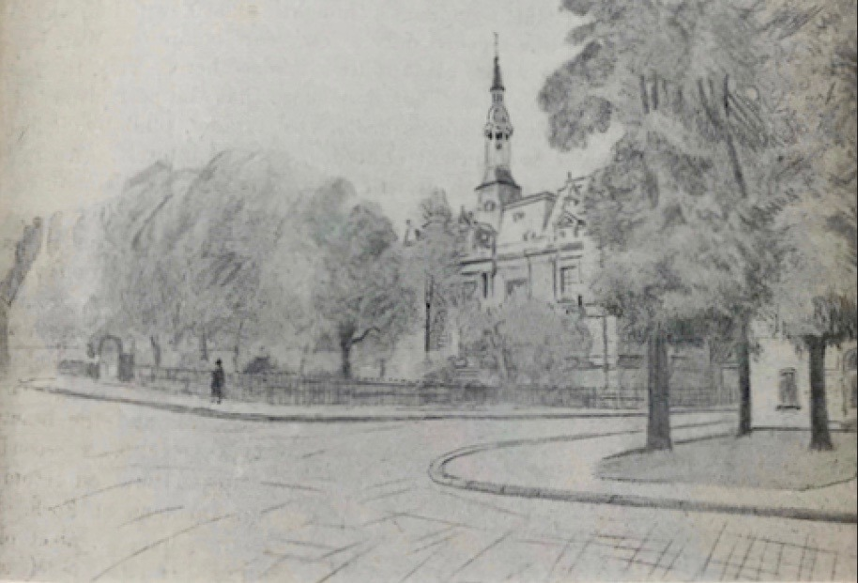
This sketch by W. Basil Worsfold was first published in "United Empire," Volume XX, London: Isaac Pitman, 1929, pg. 237. The image is in the public domain.

Vivamus in tincidunt nunc, in congue velit. Donec ac augue turpis. Aenean pretium ornare viverra. Proin sed tortor odio. Proin fermentum justo non sem venenatis, sit amet sollicitudin elit lobortis. Pellentesque at tempor massa. In interdum mattis sapien, quis volutpat elit mattis nec. Etiam sollicitudin felis vel tempor lobortis. Duis et augue imperdiet, feugiat tellus ac, faucibus nibh. Ut sodales nisl ac enim sagittis tempus. Suspendisse placerat iaculis lobortis.

APA Heading 2 (Heading 3 Style in Template)
Morbi ultricies et libero sit amet varius. Sed euismod tempor nunc, ornare ullamcorper nisl sollicitudin ut. Nulla gravida massa ut ex ullamcorper, maximus sagittis est consequat. Aenean aliquet lacus urna, vitae tincidunt mauris rhoncus id. Curabitur vehicula massa non faucibus volutpat. Donec dapibus varius enim, faucibus semper tellus molestie eget. Pellentesque habitant morbi tristique senectus et netus et malesuada fames ac turpis egestas. Duis ut pellentesque sem, eu vestibulum est. Ut nec ligula eleifend, imperdiet orci non, maximus eros. Duis blandit eros sed viverra finibus. Integer auctor vel lorem at varius. Etiam euismod magna orci, vel efficitur tellus elementum sit amet. Aliquam id pulvinar sapien. Morbi et ultrices quam, vitae placerat turpis.

APA Heading 3 (Heading 4 Style in Template)
Praesent et magna euismod massa mollis venenatis. Sed dapibus turpis eget lorem ornare eleifend. Duis ut faucibus arcu. Integer a magna egestas, pulvinar justo sit amet, dignissim risus. Mauris id eros non velit finibus sollicitudin ac sed eros. Nunc semper volutpat urna, sed viverra est mollis non. Nullam non nulla orci. Nulla mattis, dui quis mollis feugiat, neque lorem egestas massa, finibus tincidunt massa nunc eget ex. Sed sagittis elementum augue, vitae bibendum neque. Fusce vestibulum sem non nulla ullamcorper, sit amet suscipit mauris tempor. Maecenas non vehicula ligula, et consectetur diam. Phasellus tortor odio, ornare vestibulum iaculis ac, aliquet non dolor. Quisque mattis mi eget ipsum viverra rhoncus.

Insert a page break at the end of each major section by placing your cursor after the final punctuation and going to Insert > Page Break.

APA Heading 1 (Heading 2 Style in Template)
Praesent et magna euismod massa mollis venenatis. Sed dapibus turpis eget lorem ornare eleifend. Duis ut faucibus arcu. Integer a magna egestas, pulvinar justo sit amet, dignissim risus. Mauris id eros non velit finibus sollicitudin ac sed eros. Nunc semper volutpat urna, sed viverra est mollis non. Nullam non nulla orci. Nulla mattis, dui quis mollis feugiat, neque lorem egestas massa, finibus tincidunt massa nunc eget ex. Sed sagittis elementum augue, vitae bibendum neque. Fusce vestibulum sem non nulla ullamcorper, sit amet suscipit mauris tempor. Maecenas non vehicula ligula, et consectetur diam. Phasellus tortor odio, ornare vestibulum iaculis ac, aliquet non dolor. Quisque mattis mi eget ipsum viverra rhoncus.
Table 1
Table Title (Title case, manually un-bold and italicize after applying Table Title style)
Year | Number of Students
2016 | 12,923
2017 | 13,012
2018 | 11,065
2019 | 12,743
Note: Use notes to provide further explanation, as needed.
Morbi libero enim, semper at nisi in, porttitor vulputate nibh. Morbi finibus dapibus accumsan. Proin eros orci, suscipit nec imperdiet eu, facilisis ac nisl. Donec laoreet turpis orci, ac sagittis felis ultrices eget. Nunc ullamcorper id mi eu viverra. Morbi vel lobortis nunc. Mauris sit amet tempus lacus. Suspendisse pulvinar nulla sit amet interdum laoreet. Etiam sit amet metus diam. Donec bibendum egestas dignissim. Donec varius nulla ac enim imperdiet vestibulum. In hac habitasse platea dictumst. Curabitur erat velit, maximus sed scelerisque in, commodo nec augue. Vivamus fermentum enim non sagittis accumsan. Nulla porta ultricies odio, ut sollicitudin diam eleifend nec.
Table 2
Table Title (Title case, manually un-bold and italicize after applying Table Title style)
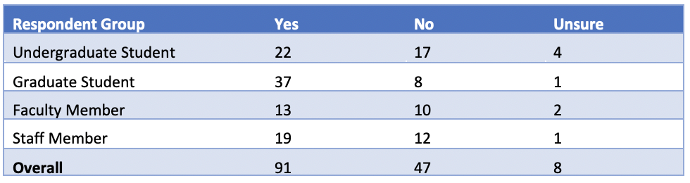
Note: Use notes to provide further explanation, as needed.
Ut tempus metus sed nibh finibus, eget bibendum erat feugiat. In quam leo, aliquam a lorem eu, ultrices blandit tortor. Sed enim lectus, scelerisque ut tristique vel, euismod et eros. Etiam erat massa, posuere sit amet sollicitudin et, efficitur sit amet metus. Ut varius neque vel est rhoncus, eu eleifend quam tincidunt. Aenean at consectetur tellus, vitae fringilla dolor. Maecenas mollis, dolor in hendrerit vulputate, sem nisl iaculis odio, sit amet faucibus urna urna id nisi.
Vivamus in tincidunt nunc, in congue velit. Donec ac augue turpis. Aenean pretium ornare viverra. Proin sed tortor odio. Proin fermentum justo non sem venenatis, sit amet sollicitudin elit lobortis. Pellentesque at tempor massa. In interdum mattis sapien, quis volutpat elit mattis nec. Etiam sollicitudin felis vel tempor lobortis. Duis et augue imperdiet, feugiat tellus ac, faucibus nibh. Ut sodales nisl ac enim sagittis tempus. Suspendisse placerat iaculis lobortis.
Figure 2
Figure Title (Title Case, manually un-bold and italicize after applying Figure Title style)
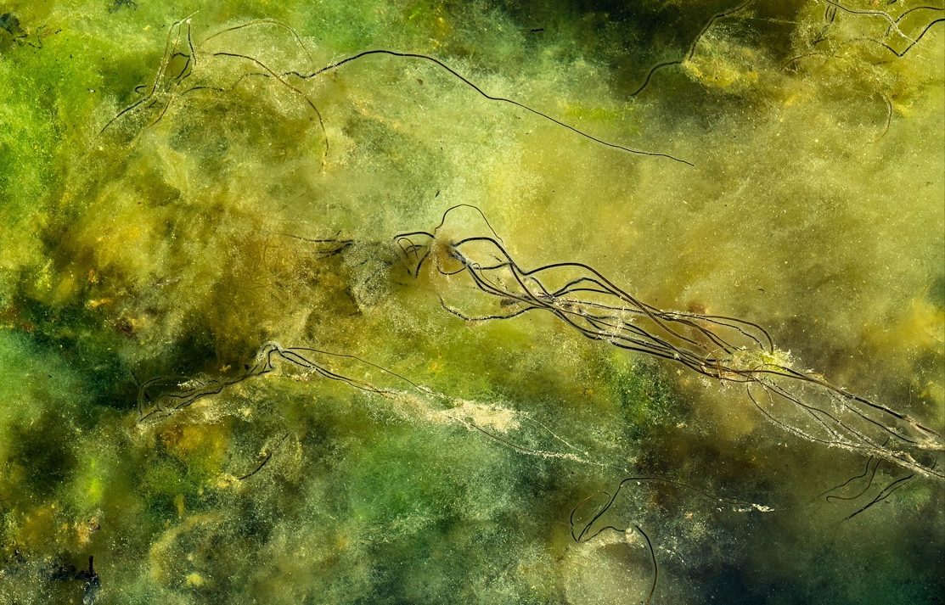
Figure 2. The Dead Man's Rope (Chorda filum) shown in this photograph are about 3.3 ft. high, and the bottom is covered with soft blanket weed (Cladophora glomerata). Photo by W.carter, CC0 1.0 Universal.
Morbi libero enim, semper at nisi in, porttitor vulputate nibh. Morbi finibus dapibus accumsan. Proin eros orci, suscipit nec imperdiet eu, facilisis ac nisl. Donec laoreet turpis orci, ac sagittis felis ultrices eget. Nunc ullamcorper id mi eu viverra. Morbi vel lobortis nunc. Mauris sit amet tempus lacus. Suspendisse pulvinar nulla sit amet interdum laoreet. Etiam sit amet metus diam. Donec bibendum egestas dignissim. Donec varius nulla ac enim imperdiet vestibulum. In hac habitasse platea dictumst.

Insert a page break at the end of each major section by placing your cursor after the final punctuation and going to Insert > Page Break.

References
Grady, J. S., Her, M., Moreno, G., Perez, C., & Yelinek, J. (2019). Emotions in storybooks: A comparison of storybooks that represent ethnic and racial groups in the United States. Psychology of Popular Media Culture, 8(3), 207–217.
Shulte, Bret. “Putting a Price on Pollution.” US News & World Report, vol. 142, no. 17, 14 May 2007, p. 37. Ebsco, Access no: 24984616.

Insert a page break at the end of each major section by placing your cursor after the final punctuation and going to Insert > Page Break.

Appendix/Appendices
Appendix A: List of California State University Campuses
California State University, Bakersfield
California State University Channel Islands
California State University, Chico
California State University, Dominguez Hills
California State University, East Bay
California State University, Fresno
California State University, Fullerton
Humboldt State University
California State University, Long Beach
California State University, Los Angeles
California State University Maritime Academy
California State University, Monterey Bay
California State University, Northridge
California State Polytechnic University, Pomona
California State University, Sacramento
California State University, San Bernardino
San Diego State University
San Francisco State University
San José State University
California Polytechnic State University, San Luis Obispo
California State University San Marcos
Sonoma State University
California State University, Stanislaus

Appendix B: Abbreviations of California State University Campuses
CSU Bakersfield
CSU Channel Islands
Chico State
CSU Dominguez Hills
Cal State East Bay
Fresno State
Cal State Fullerton
Humboldt State
Cal State Long Beach
Cal State LA
Cal Maritime
CSU Monterey Bay
CSUN
Cal Poly Pomona
Sacramento State
Cal State San Bernardino
San Diego State
San Francisco State
San José State
Cal Poly San Luis Obispo
CSU San Marcos
Sonoma State
Stanislaus State

